

NATIONAL UNIVERSITY OF TECHNOLOGY ISLAMABAD
DEPARTMENT OF COMPUTER SCIENCE
DIGITAL LOGIC DESIGN LAB

Name | Bisma Fatima
Roll No | 36
Batch | 24
Section | A
Lab Number | 04
Instructor Name | Sir Haseeb  Miss Tehreem khalil
Date of Submission | March 24TH, 2025
Topic Covered | OEL 01

Experiment 5
Designing a Combinational Circuit using Logic Gates
(Open Ended Lab)
Objective
- Design, construct and test combinational circuits using logic gates.
Design Problem
Design a combinational circuit with four inputs A, B, C and D and one output F. F is to be equal to 1 when A = 1, provided that B = 0, or when B = 1, provided that either C or D is equal to 1. Otherwise, the output is equal to 0.
Design, draw and implement the circuit using any type of logic gates with minimum number of ICs.
- Obtain the truth table of the circuit and simplify the output function.
- List out the ICs required.
- Write down the steps of the procedure.
Tools/Equipment Requirement
Identify and list down
The circuit requires basic logic gates. The standard ICs needed are:
● 7404 (NOT gate) – to invert B.
● 7408 (AND gate) – for AND operations.
● 7432 (OR gate) – for OR operations.
Activity Time Boxing

Task No. | Activity Name | Activity Time
1 | Explaining Problem Statement | 10 ~ 15 mins
2 | Building up logic | 15 ~ 20 mins
3 | Draw a logic diagram | 10 ~ 15mins
4 | Identify the equipment required | 10 ~ 15 mins
5 | Devising a procedure to get the required output | 90~95min
6 | Output Verification and Viva | 15 ~ 20 mins
Total Time: 180

Understanding the Problem Statement:
We need to design a combinational circuit with four inputs (A, B, C, D) and one output (F). The output F = 1 under the following conditions:
1. When A = 1, provided that B = 0.
2. When B = 1, provided that either C or D is 1.
3. Otherwise, F = 0.
This means the Boolean function should be designed based on these conditions.

Constructing the Boolean Expression:
1. The first condition (A = 1, B = 0) can be written as:
A⋅B`
2. The second condition (B = 1 and (C = 1 or D = 1)) can be written as:
B`⋅(C + D)
3. Combining both expressions using OR (since either condition can make F = 1):
F=(A⋅B`)+A(B⋅(C+D))
Simplified:
1. The given Boolean expression is:
- F=(A⋅ B`)+A(B⋅ (C+D))
- F=(A⋅ B`)+(A⋅ B⋅ C)+(A⋅ B⋅ D)
- F=A(B`+B⋅ C+B⋅ D) //simplified form
Procedure:
Step 1: Truth Table Generation
- Generate all possible input combinations (16 cases) for inputs A, B, C, and D.
- Calculate the output F for each case using the given Boolean equation.
Step 2: Boolean Expression Simplification
- Minimize the Boolean equation, if possible, to reduce complexity.
Step 3: Circuit Design
- Design a digital circuit diagram based on the simplified Boolean equation.
- Utilize logic gates (AND, OR, NOT, etc.) to implement the Boolean function.
Step 4: Circuit Assembly and Simulation
- Assemble the designed circuit on a breadboard or simulate it using software.
- Place integrated circuits (ICs) and connect them according to the circuit diagram.
Step 5: Circuit Verification
- Apply all 16 test cases from the truth table to the assembled or simulated circuit.
- Compare the actual output with the expected output from the truth table to verify the circuit's correctness.

Logic/Circuit Diagram
Circuit Verse Logic Diagram:
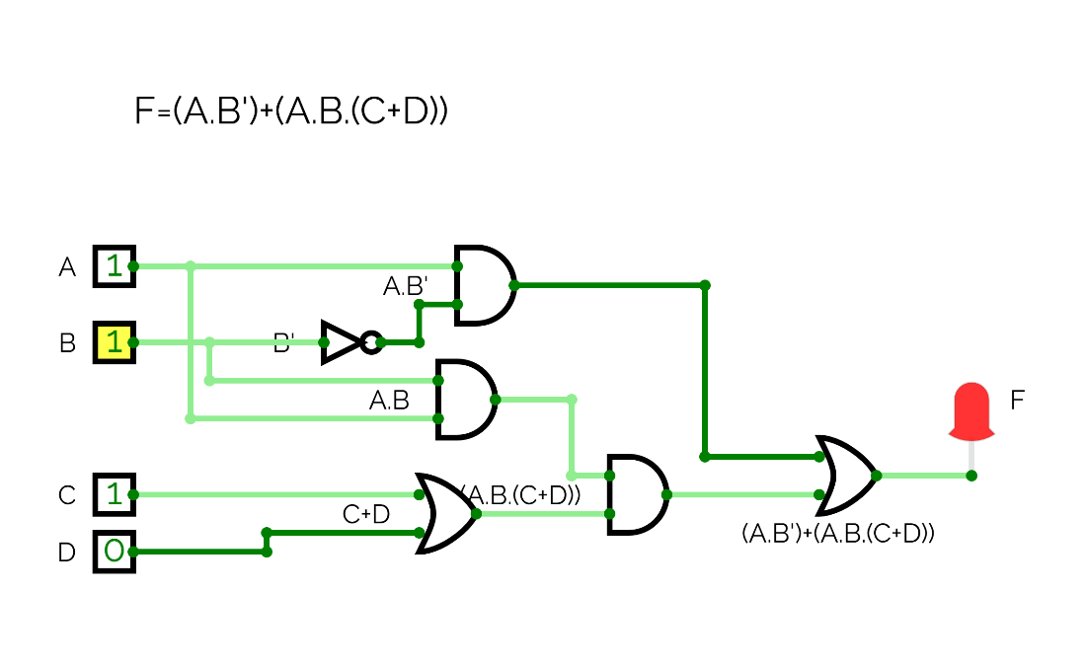

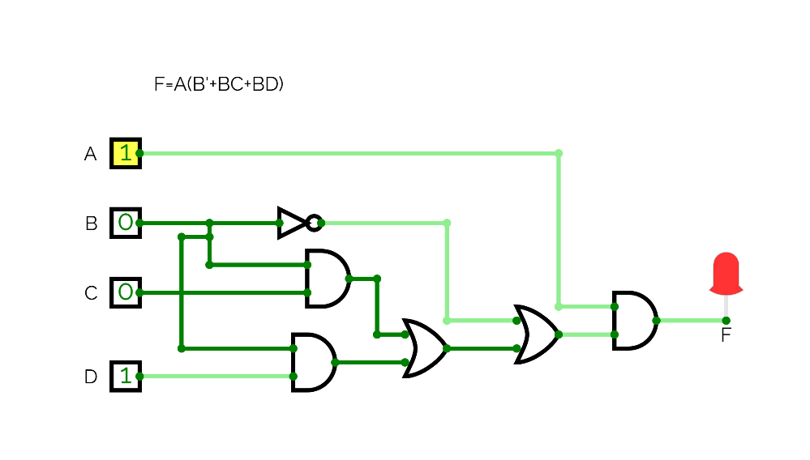

Circuit:
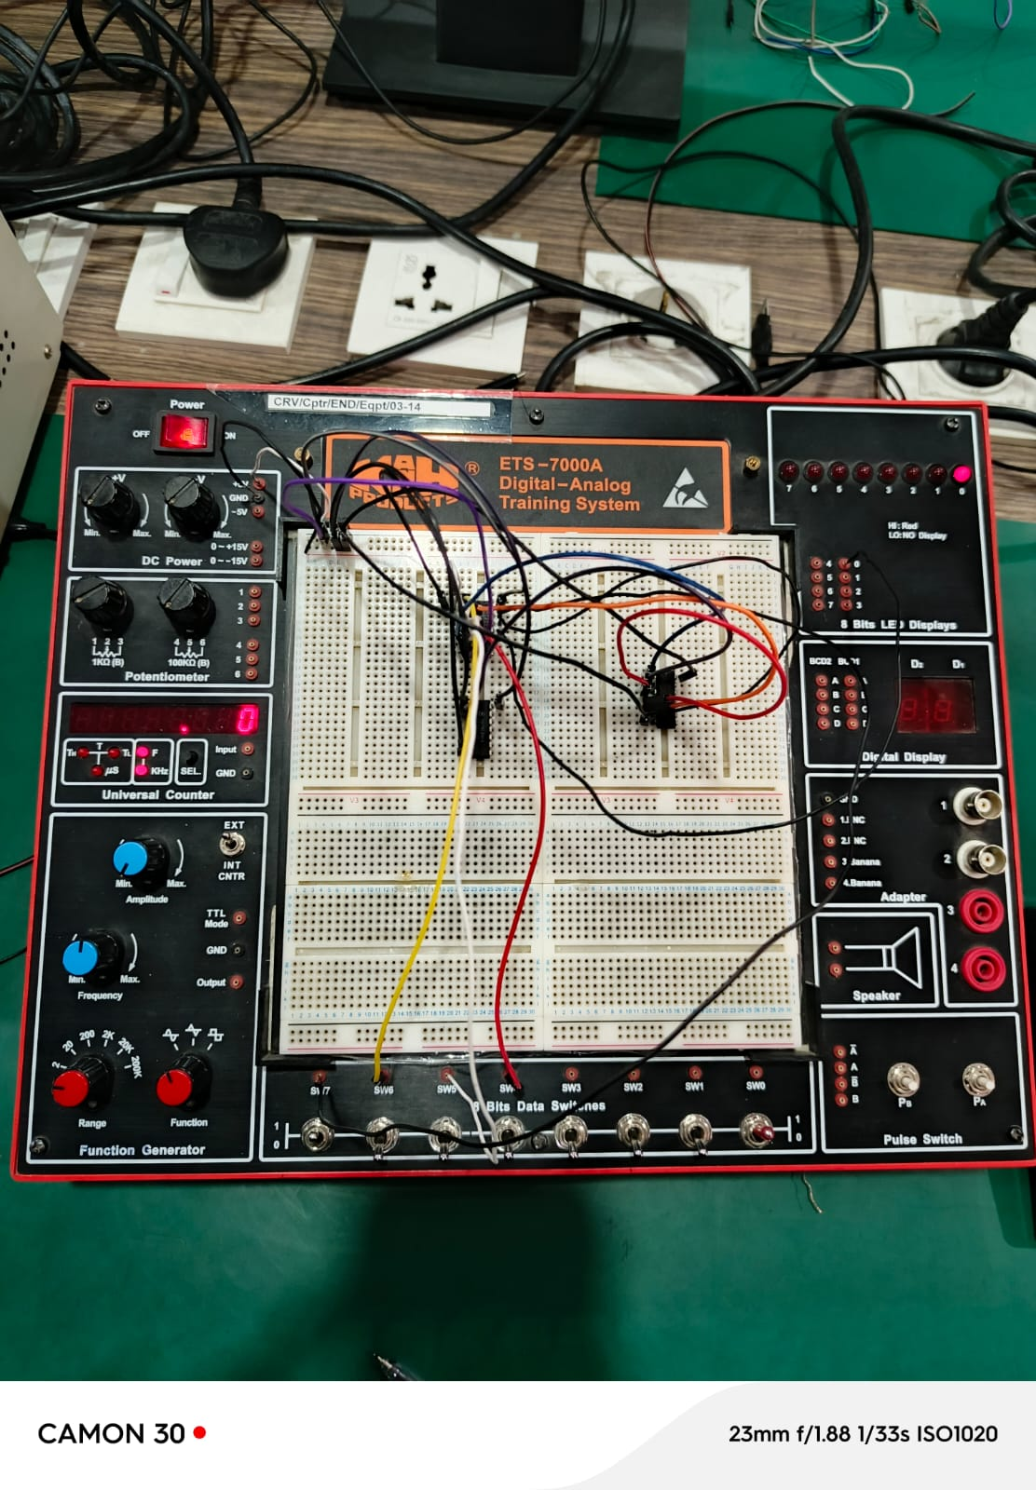

Observations/Truth Table

INPUTS |  |  |  | Expression  (Solve theoretically)
A | B | C | D | F
0 | 0 | 0 | 0 | 0
0 | 0 | 0 | 1 | 0
0 | 0 | 1 | 0 | 0
0 | 0 | 1 | 1 | 0
0 | 1 | 0 | 0 | 0
0 | 1 | 0 | 1 | 1
0 | 1 | 1 | 0 | 1
0 | 1 | 1 | 1 | 1
1 | 0 | 0 | 0 | 1
1 | 0 | 0 | 1 | 1
1 | 0 | 1 | 0 | 1
1 | 0 | 1 | 1 | 1
1 | 1 | 0 | 0 | 0
1 | 1 | 0 | 1 | 1
1 | 1 | 1 | 0 | 1
1 | 1 | 1 | 1 | 1

Learning Outcomes
- Learn Boolean algebra
- Design digital circuits
- Simplify circuits
- Build and test circuits

